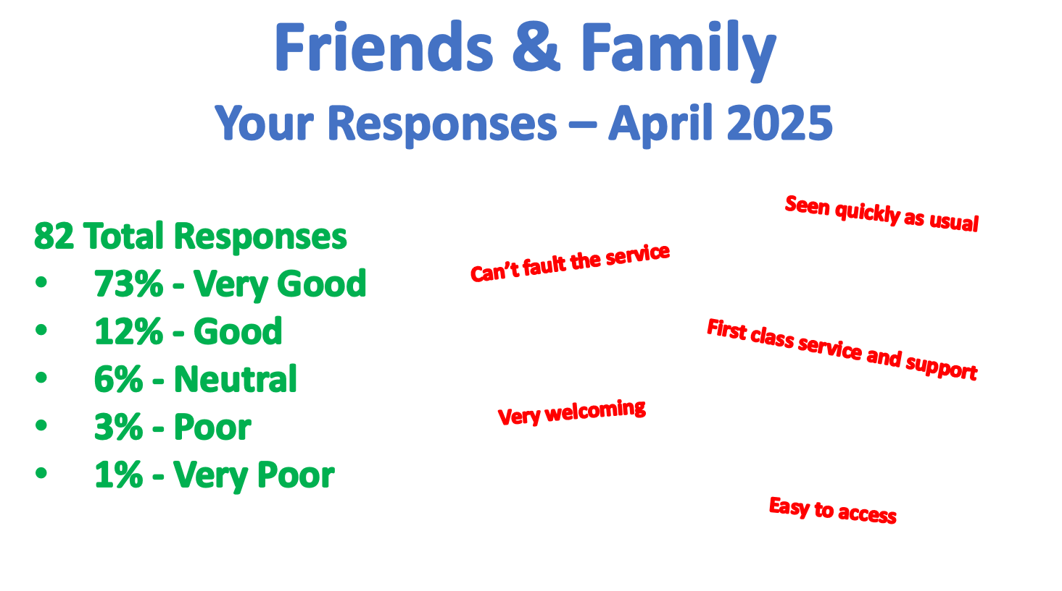

Friends and family

Your responses April 2025

82 total responses

* 73% very good
* 12% good
* 6% neutral
* 3% poor
* 1% very poor

Seen quickly as usual

Can’t fault the service

First class service and support

Very welcoming

Easy to access